**ARPP Calculation**

1. Create Product with “Other Product” record type.
2. Create commission record for each Product record. But commission amount is varying based on Asset Type (Equity/Gold/Debt/Liquid). Therefore need to crate multiple commission record acc to asset type.

Note. Asset Type field is not present on Action Plan SIP or Lumpsum Section but Asset values available in other filed “Category”.

1. **Action Plan Changes** : All text boxes where product is recommended has to be changed to drop-down and the corresponding product list from product master needs to be displayed
2. Create new object to store Action plan record Upfront and trail commission calculate value and

AP associated Execution tracker upfront and trail commission value.

`

1. Trigger to handle upfront or trail and both commission calculation. Trigger will executed while Execution tracker records.
2. Develop VF page to display ARPP Detail for particular entity. This page will launch from Entity Detail page custom button. Page mockup is below :

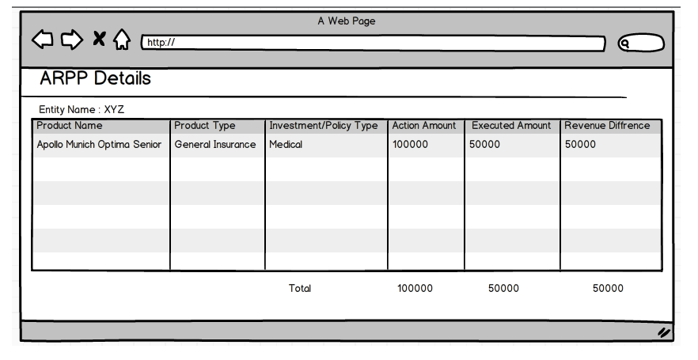

Here we are displaying few fields on Mockup design. Mockup will contain following fields:

1. Product Name
2. Product Type
3. Investment/Policy Type
4. Action Amount
5. Action Amount Upfront comm.
6. Action Amount Trail comm.
7. Action Amount Revenue
8. Executed Amount
9. Executed Amount Upfront Comm.
10. Executed Amount Trail Comm.
11. Executed Amount Revenue
12. Revenue Difference